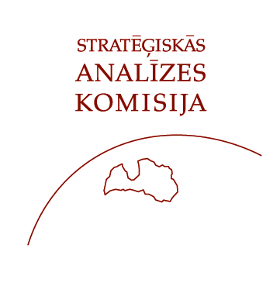

The Strategic Analysis Commission under the Auspices of the President of Latvia in cooperation with
the Royal Danish Embassy
and the Danish Cultural Institute

Discussion Club on Climate Change

“Public Awareness and Social Attitudes towards Climate Change:
Latvian and Danish Perspectives”

March 19, 2008, Riga Castle

14.00 Introductory remarks

Mrs. Gunda Reire, Strategic Analysis Commission
Minister Counsellor Mr. Carl Balle Petersen, Royal Danish Embassy

14.10 Latvia’s View of the Climate Change: Presentation of Opinion Poll Results

Presentation: Mrs. Aija Lulle, Strategic Analysis Commission
Comment: Mr. Arnis Kaktiņš, SKDS

14.25 Global and National Perspectives on Climate Change

Remarks: Mr. Carl Balle Petersen, Royal Danish Embassy
Mr. Simon Drewsen Holmberg, Danish Cultural Institute
Comment: Mr. Toms Rostoks, University of Latvia

14.40 Discussion

15.20 Conclusions

Mrs. Gunda Reire, Strategic Analysis Commission
Minister Counsellor Mr. Carl Balle Petersen, Royal Danish Embassy

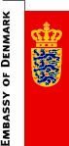

15.30 Coffee

